**Math Homework**

**1. Draw a line from each analog clock to the correct matching digital clock.**

[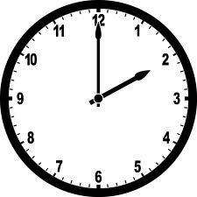](http://www.google.com/imgres?imgurl=http://etc.usf.edu/clipart/33700/33714/nclock-02-00_33714_lg.gif&imgrefurl=http://etc.usf.edu/clipart/galleries/476-arabic-numeral-clocks-hour-2&h=1024&w=1024&sz=35&tbnid=bYOzeV6obELtEM:&tbnh=90&tbnw=90&zoom=1&usg=__zUGgCx0YHTTie6utS5Dg6hhbQpk=&docid=V7q13eHlLMAuQM&sa=X&ei=XtU1UvfcDsv54APLyYA4&ved=0CCsQ9QEwAA&dur=1088)

[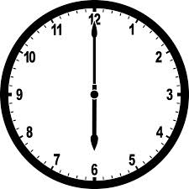](http://www.google.com/imgres?imgurl=http://etc.usf.edu/clipart/33900/33954/nclock-06-00_33954_lg.gif&imgrefurl=http://etc.usf.edu/clipart/galleries/480-arabic-numeral-clocks-hour-6&h=1024&w=1024&sz=35&tbnid=g0xPEoG7_3-zmM:&tbnh=90&tbnw=90&zoom=1&usg=__3b-PJejqh70BxziQC8HrSReJGo0=&docid=b0ntvCBdaebKTM&sa=X&ei=idU1UrPJFbiu4AOj5YCABw&ved=0CC4Q9QEwAQ&dur=35)

[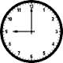](http://www.google.com/imgres?imgurl=http://www.say-it-in-english.com/EverydayEnglish/Clocks/nine%20o'clock.gif&imgrefurl=http://www.say-it-in-english.com/TellingTime.html&h=100&w=100&sz=2&tbnid=M279XG4tA_mi5M:&tbnh=80&tbnw=80&zoom=1&usg=__GuiMDZ3Fh-mhczIVZJYBwRvW0yc=&docid=eGXPuUK8lsJioM&sa=X&ei=xNU1Ut_7NPf_4AOCkoCwCw&ved=0CDEQ9QEwAg&dur=573)

**2. Show as many ways as you can to make the number 6.**

**5+1=6**

[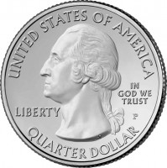](http://www.parkquarters.com/wp-content/uploads/2009/11/Park-Quarter-Obverse-Design.jpg)

[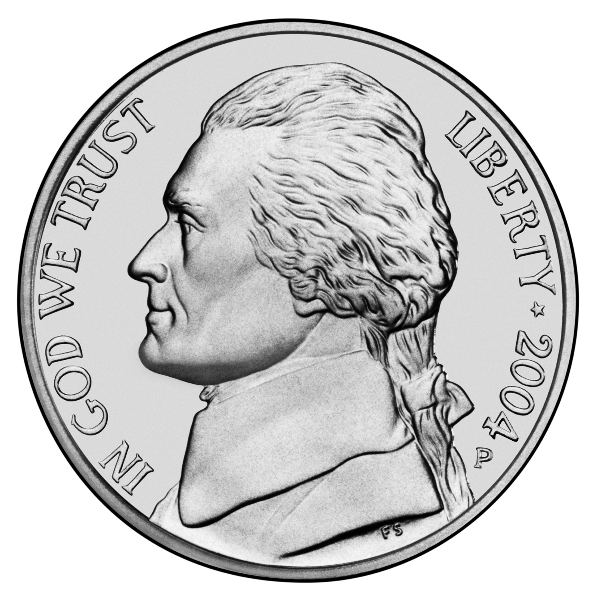](http://www1.bellevuepublicschools.org/curriculum/k6web/firstgrade/money/mixespennynickel1.htm)

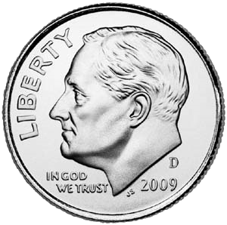

[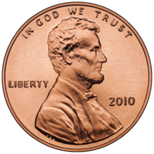](http://en.wikipedia.org/wiki/File:2010_cent_obverse.png)

[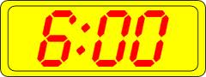](http://www.google.com/imgres?imgurl=http://www.clker.com/cliparts/4/6/0/d/12236134351831335773manio1_Digital_Clock_10.svg.med.png&imgrefurl=http://www.clker.com/clipart-digital-clock.html&h=113&w=300&sz=7&tbnid=C6jJjMFH15bV9M:&tbnh=46&tbnw=122&zoom=1&usg=__r_0nGpYS_tLTU3euTV78KKeeuOM=&docid=3K7pVM38IGXZYM&sa=X&ei=Etc1Up_6Bo-p4AOslICwCA&ved=0CC4Q9QEwAQ&dur=299)

[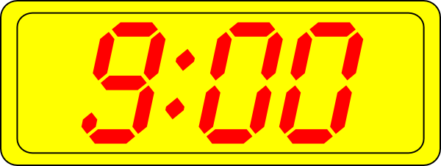](http://www.google.com/url?sa=i&source=images&cd=&cad=rja&docid=yeQsKU1TdtbfSM&tbnid=uQmnbYYFUXXIFM:&ved=0CAgQjRwwAA&url=http://www.clker.com/clipart-digital-clock-18.html&ei=fdY1UuKjJfS44AO814GIAw&psig=AFQjCNGlP4SqVDkDEFYoeGcIJmi_Jtde6Q&ust=1379346429638206)

[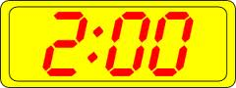](http://www.google.com/imgres?imgurl=http://www.clker.com/cliparts/8/a/e/2/12236133801367466775manio1_Digital_Clock_2.svg.med.png&imgrefurl=http://www.clker.com/clipart-digital-clock-8.html&h=113&w=300&sz=6&tbnid=9e0InEA6-vxGtM:&tbnh=49&tbnw=130&zoom=1&usg=__lbdUBzVPv5HBObMpwKIyn6Td1_0=&docid=1mTsKtBPTAWnBM&sa=X&ei=S9Y1Uu_OBavi4APBtoH4Dg&ved=0CDEQ9QEwAg&dur=541)

**3. Write the name of each coin on the line and draw a line to match each coin to the correct value.**

**________ 1¢**

**________ 5¢**

**________ 10¢**

**________ 25¢**

**4.Fill in the missing numbers.**



11

12

____

14

15

49

____

51

52

____

56

57

58

_____

**6. Mrs. Kelly has 20 notebooks. There are 24 students in her class.**

**Are there enough notebooks for the class?**

**Yes No**

**Does Mrs. Kelly need more notebooks?**

**Yes No**

**How many?____________________**

**5. Ms. White has 24 notebooks. There are 18 students in Ms. White’s class.**

**Are there enough notebooks for the class?**

**Yes No**

**Are there any extra notebooks?**

**Yes No**

**How many?____________________**